**1. Top right corner of Wet Kitchen:**

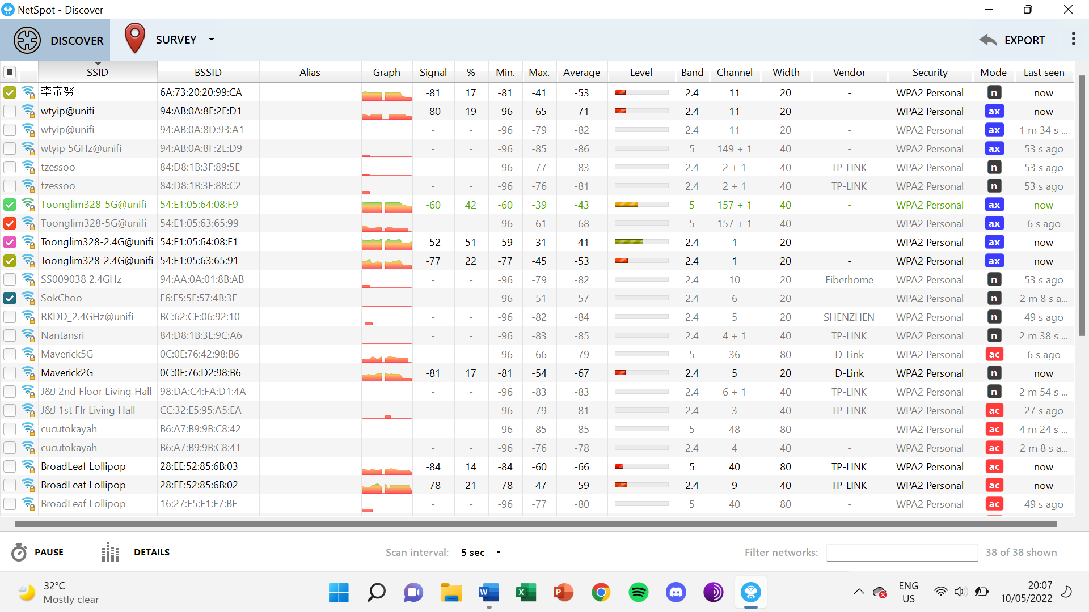

**2. Top left corner of Guest Bedroom:**

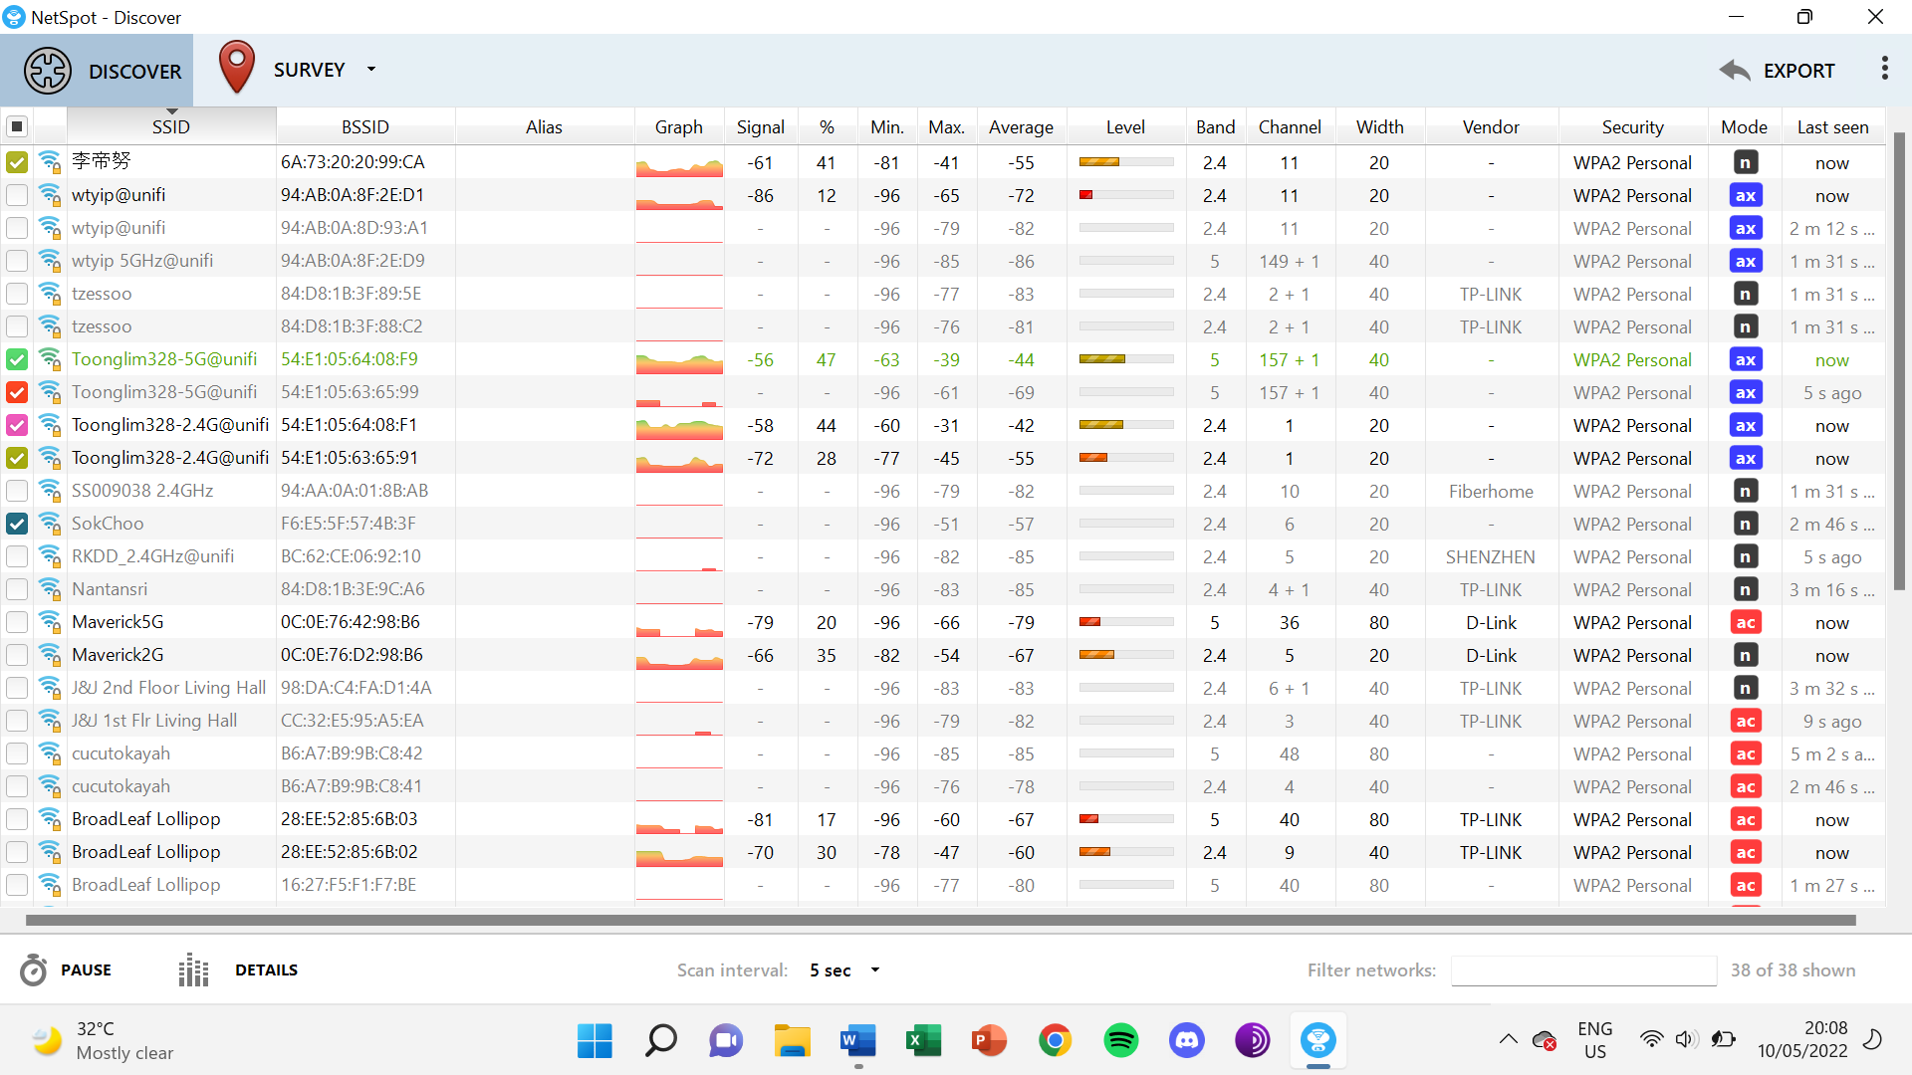

**3. Bottom left corner of stairs:**

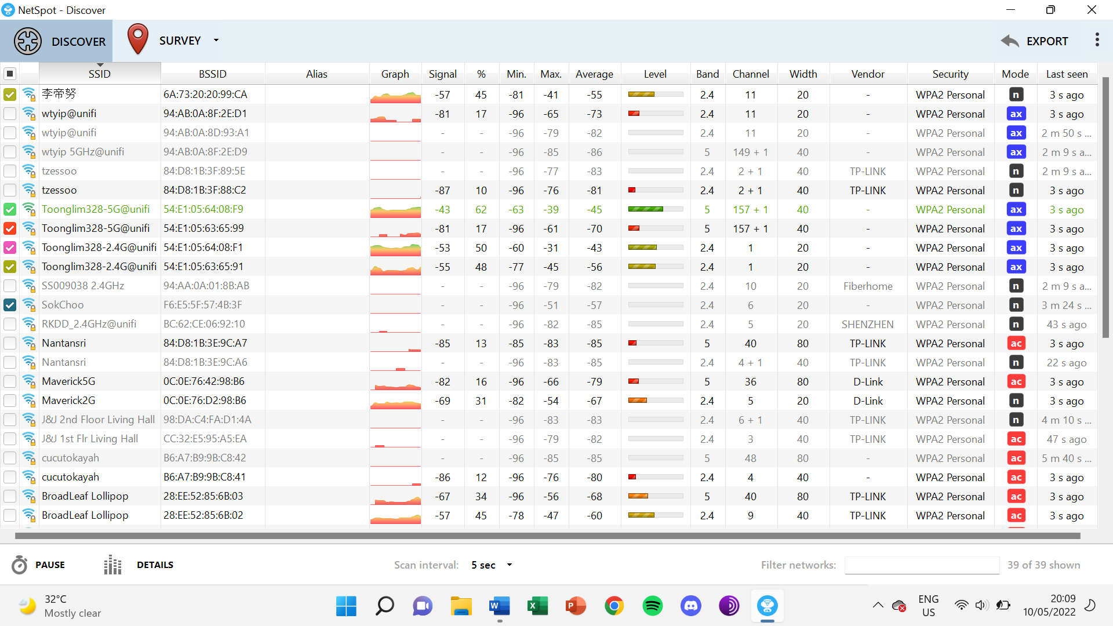

**4. Middle part of Dining room:**

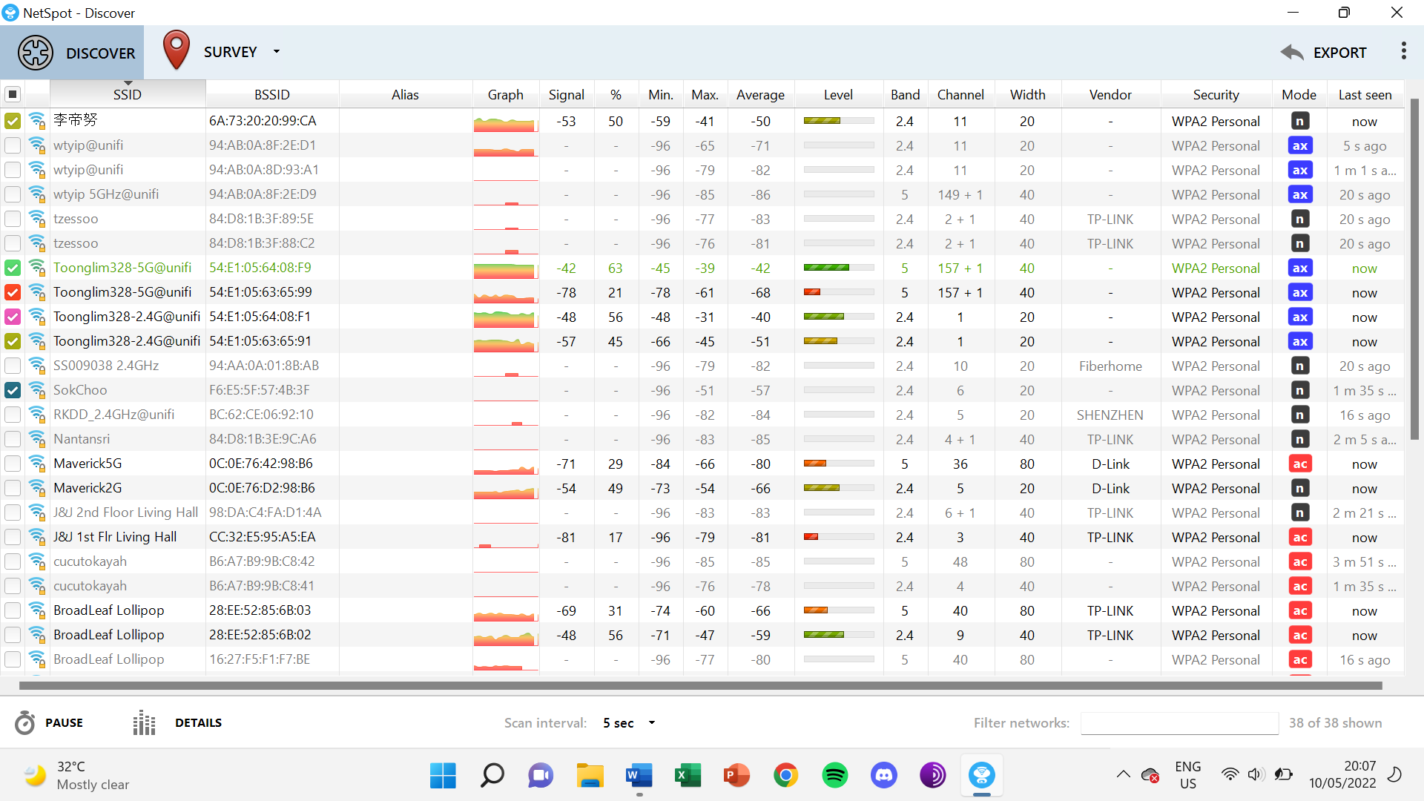

**5. Middle of Dining room (on top of dining table):**

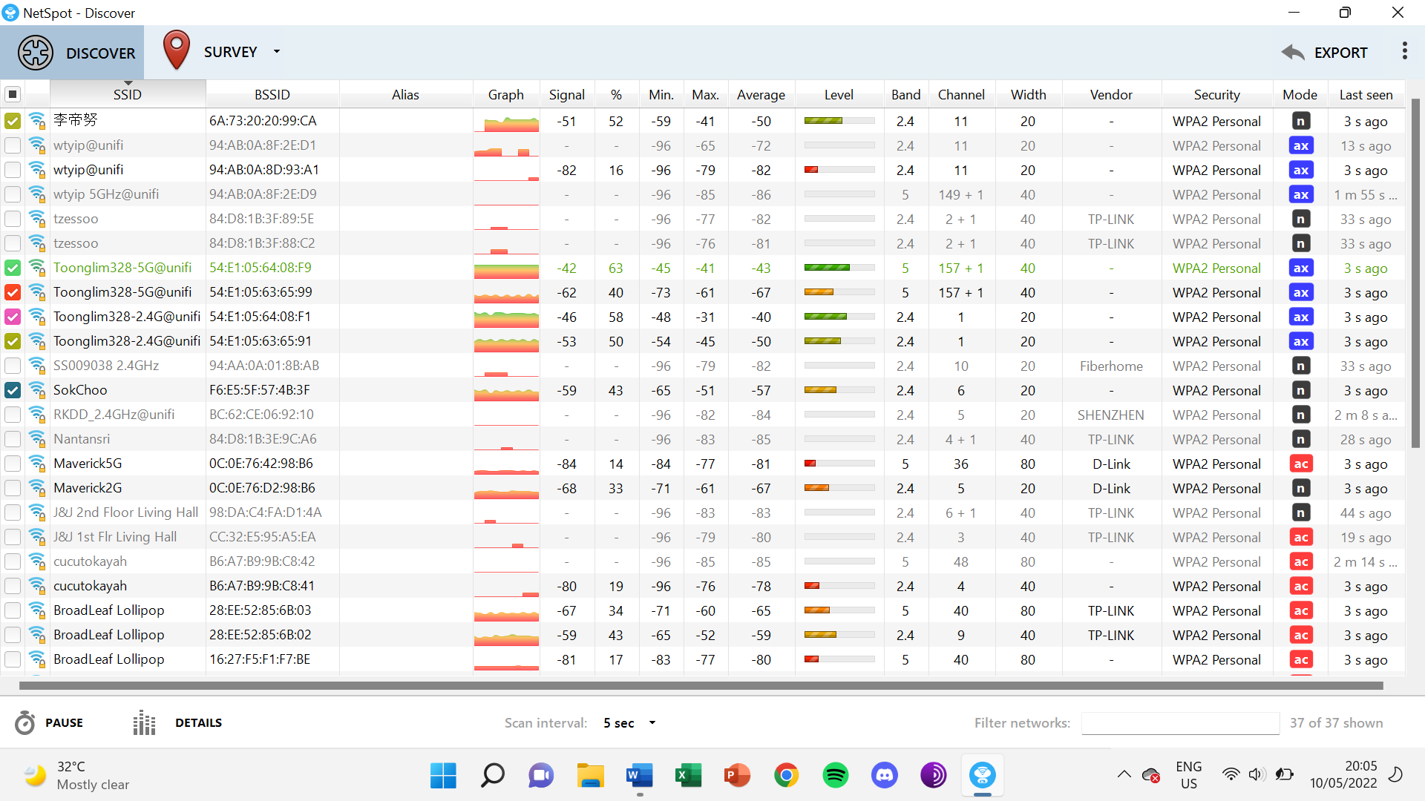

**6. Right side near fence wall of side garden:**

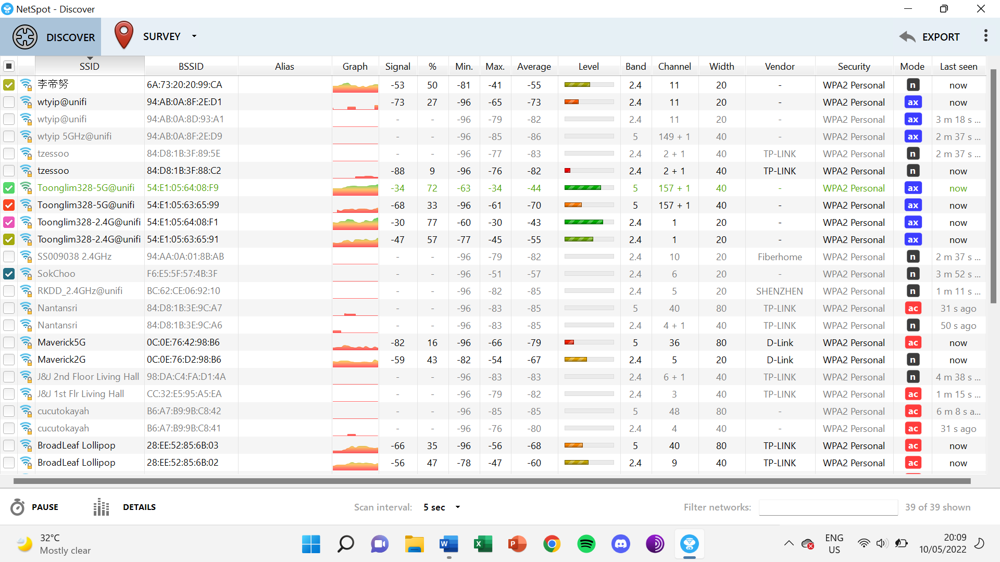

**7. Bottom left corner of Car Porch:**

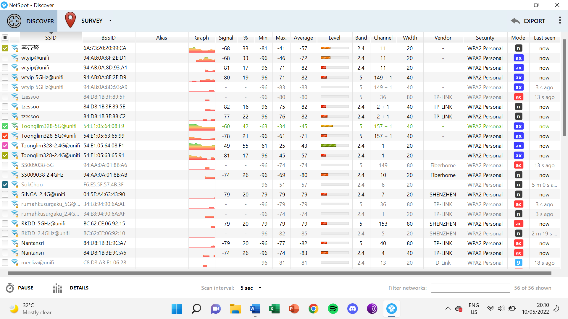

**8. Bottom right corner of Car Porch:**

